**DAA ASSIGNMENT-2**

**SET-A**

Q1. Solve using fractional knapsack:

M=20, n=4

P= (3, 10, 15, 5)

W= (5, 13, 12, 8).

Q2. A networking company uses a compression technique to encode the message before transmitting over the

network. Suppose the message contains the following characters with their frequency:



If the compression technique used is Huffman Coding, how many bits will be saved in the message?

Q3. Find minimum spanning tree using prim and kruskal’s algorithm:



Q4. Write algorithm for matrix chain multiplication and solve the given sequence matrices:

P=<30, 35, 15, 5, 10, 20, 3>

**DAA ASSIGNMENT-2**

**SET-B**

Q5. Find longest common subsequence for:

A=<1001010> B=<10011>

Q6. Find minimum spanning tree of the following graph using Prim’s algorithm. (start vertex=a)

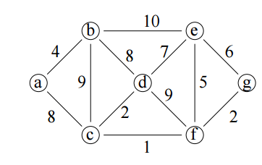

Q7. Given coins of 3 denominations i.e. c [] = {1,2,3} and an amount A=5, find the total no. of ways in which

amount A can be paid using coins of all 3 denominations and assume that we have an infinite supply of

coins of given denominations.

Q8. Solve the following instance of 0/1 Knapsack problem using Dynamic programming

n = 3; (W1, W2, W3) = (3, 5, 7);

(P1, P2, P3) = (3, 7, 12); M = 4.